Division of Composite Engineering
26 Taber Lane, Westport MA 02790, USA
www.vandusenracingboats.com
vdrbcs@gmail.com
+1 (508) 788-4466

Thank you for your order. Please read and complete all pages of this contract and send us a signed copy of the contract. We will sign and return a copy of the contract to you. If you have any questions, we will be happy to answer them.
Name
Address
City State Zip Code
Mobile telephone number
Alternative telephone number
Email address

NOTICE TO BUYER
Payment. All shell orders must be accompanied by a $500 initial deposit. We cannot accept sales orders without a deposit. A second deposit of $3,500 for a single shell or $5,500 for a double/pair is due before construction starts. The balance is due upon completion of your order, before the boat leaves our facility.
Termination and cancellation. Buyer may cancel and terminate this order provided that written notice of such termination is received by the Seller prior to the Seller's commencement of work on the boat described in this order. In the event of such cancellation and termination, the Seller shall retain $100.00 of the deposit paid hereunder to cover scheduling and handling charges. Termination of this Agreement after the Seller's commencement of work on the boat shall constitute default by the Buyer. Upon such default, the Buyer’s full deposit may be retained by the Seller as liquidated damages unless the Seller otherwise notifies the buyer in writing within 30 days after such cancellation, in which case the Seller shall retain all other remedies in law and in equity.
Default. In the event of any default by the Buyer under this Agreement, the Seller shall be entitled to recover from the Buyer all losses and costs or collection including, but not limited to, reasonable attorney's fees.
Completion date. The Seller will make every reasonable effort to complete the above-described racing boat and equipment by the date specified in our order confirmation letter. On this date, the boat will be ready at the Seller's place of business for pickup or delivery. The Buyer agrees to hold the Seller harmless for reasonable delays in completion due to causes other than the fault of the Seller.
Delivery. Unless otherwise agreed, delivery of the above-described boat and equipment shall be at the Seller's place of business. The Buyer acknowledges that transportation of the goods sold under this sales agreement is the responsibility of the Buyer. As a service to our customers, CEI will help arrange safe transport, but is not responsible for delivery charges, problems or delays.
Buyer's commitment not to copy. The Buyer hereby acknowledges that the design features of Van Dusen Racing Boats constitute property matters and that the reproduction of the Van Dusen Racing Boat, or any other product manufactured by Van Dusen Racing Boats / Composite Engineering, is the exclusive property right of the Seller. Therefore, the Buyer undertakes, covenants, and agrees not to copy or reproduce the Van Dusen Racing Boat or any other Van Dusen or Composite Engineering product, either directly or indirectly, nor will the Buyer permit anyone acquiring or using the Van Dusen Racing Boat or Composite Engineering product to copy or reproduce it. Buyer, for self, heirs, and assigns covenants and agrees that violation of the foregoing constitutes an immediate irreparable injury, not compressible to damages alone and that, in the case of violation, the Seller shall be entitled to injunctive relief. CEI shell hull designs are copyright protected. Significant legal penalties will arise from making unlicensed copies.
Warranty. The goods sold hereby are warranted to be free of defects of workmanship or materials for a period of one year from the date of delivery. All claims under this warranty must be received by the Seller within said one year period. There are no other warranties, express or implied by contract, statute, or common law, or merchantability, fitness for a particular purpose, or otherwise. Modifications to the goods manufactured by the Seller are not covered by the Seller's warranty and may void the warranty. In all cases the Buyer's remedy for the breach of warranty shall be limited to return of the goods and repayment of the price paid, or replacement of the goods, all at the Seller's option. In no case shall the Seller be liable for any consequential damages, whether for personal injury or otherwise.
Buyer’s name Seller’s name______________________________
Buyer’s signature Seller’s signature___________________________
Date __________________________________________ Date _____________________________________

Division of Composite Engineering, Inc (CEI)
26 Taber Lane, Westport MA 02790, USA
www.vandusenracingboats.com
vdrbcs@gmail.com
+1 (508) 788-4466

VAN DUSEN ADVANTAGE
The base price for the Van Dusen Advantage includes a lightweight carbon-fiber monocoque hull and solid deck, black Van Dusen carbon-fiber aerofoil wing, inverted splashboard, Dreher carbon seat with Carl Douglas anodized aluminum tracks, and Concept2 oarlocks with titanium pins.

Van Dusen Advantage single with carbon-fiber aerofoil wing rigger $16,500
Van Dusen Advantage double or pair with carbon-fiber aerofoil wing riggers $24,500
Van Dusen Advantage double without riggers $18,000

Standard Colors: White, Light Grey, Forest Green, Navy (medium) Blue, Light Blue.
Tape Colors: White, Black, Red, Blue, Yellow, Orange, Green
Two tone (hull and deck separate standard colors) $300.00
Custom paint Inquire

Footboard: H2Row shoes come standard with our shells. We have shoe plates to fit other brands. Please inquire for details.

ACCESSORIES
BOAT RACKS – Van Dusen Advantage Shell Rack – easily attach your boat with or without the wing; attach sculls
Van Dusen boat rack for single $300.00
Van Dusen boat rack for double $330.00
Custom mounting hardware (set of two, for aero and other style car racks) $60.00

BOAT COVERS – Custom boat covers, wing rigger covers, and oar covers should be ordered directly from Burnham Boat Slings or Next Covers. Visit www.nextcover.net and www.burnhamboatslings.com to see fabric, style, and color options as well as prices. Covers can be factory shipped to CEI for delivery with the boat, if so desired.

Note that Massachusetts sales tax is due on all orders shipped within Massachusetts or picked up at our workshop.

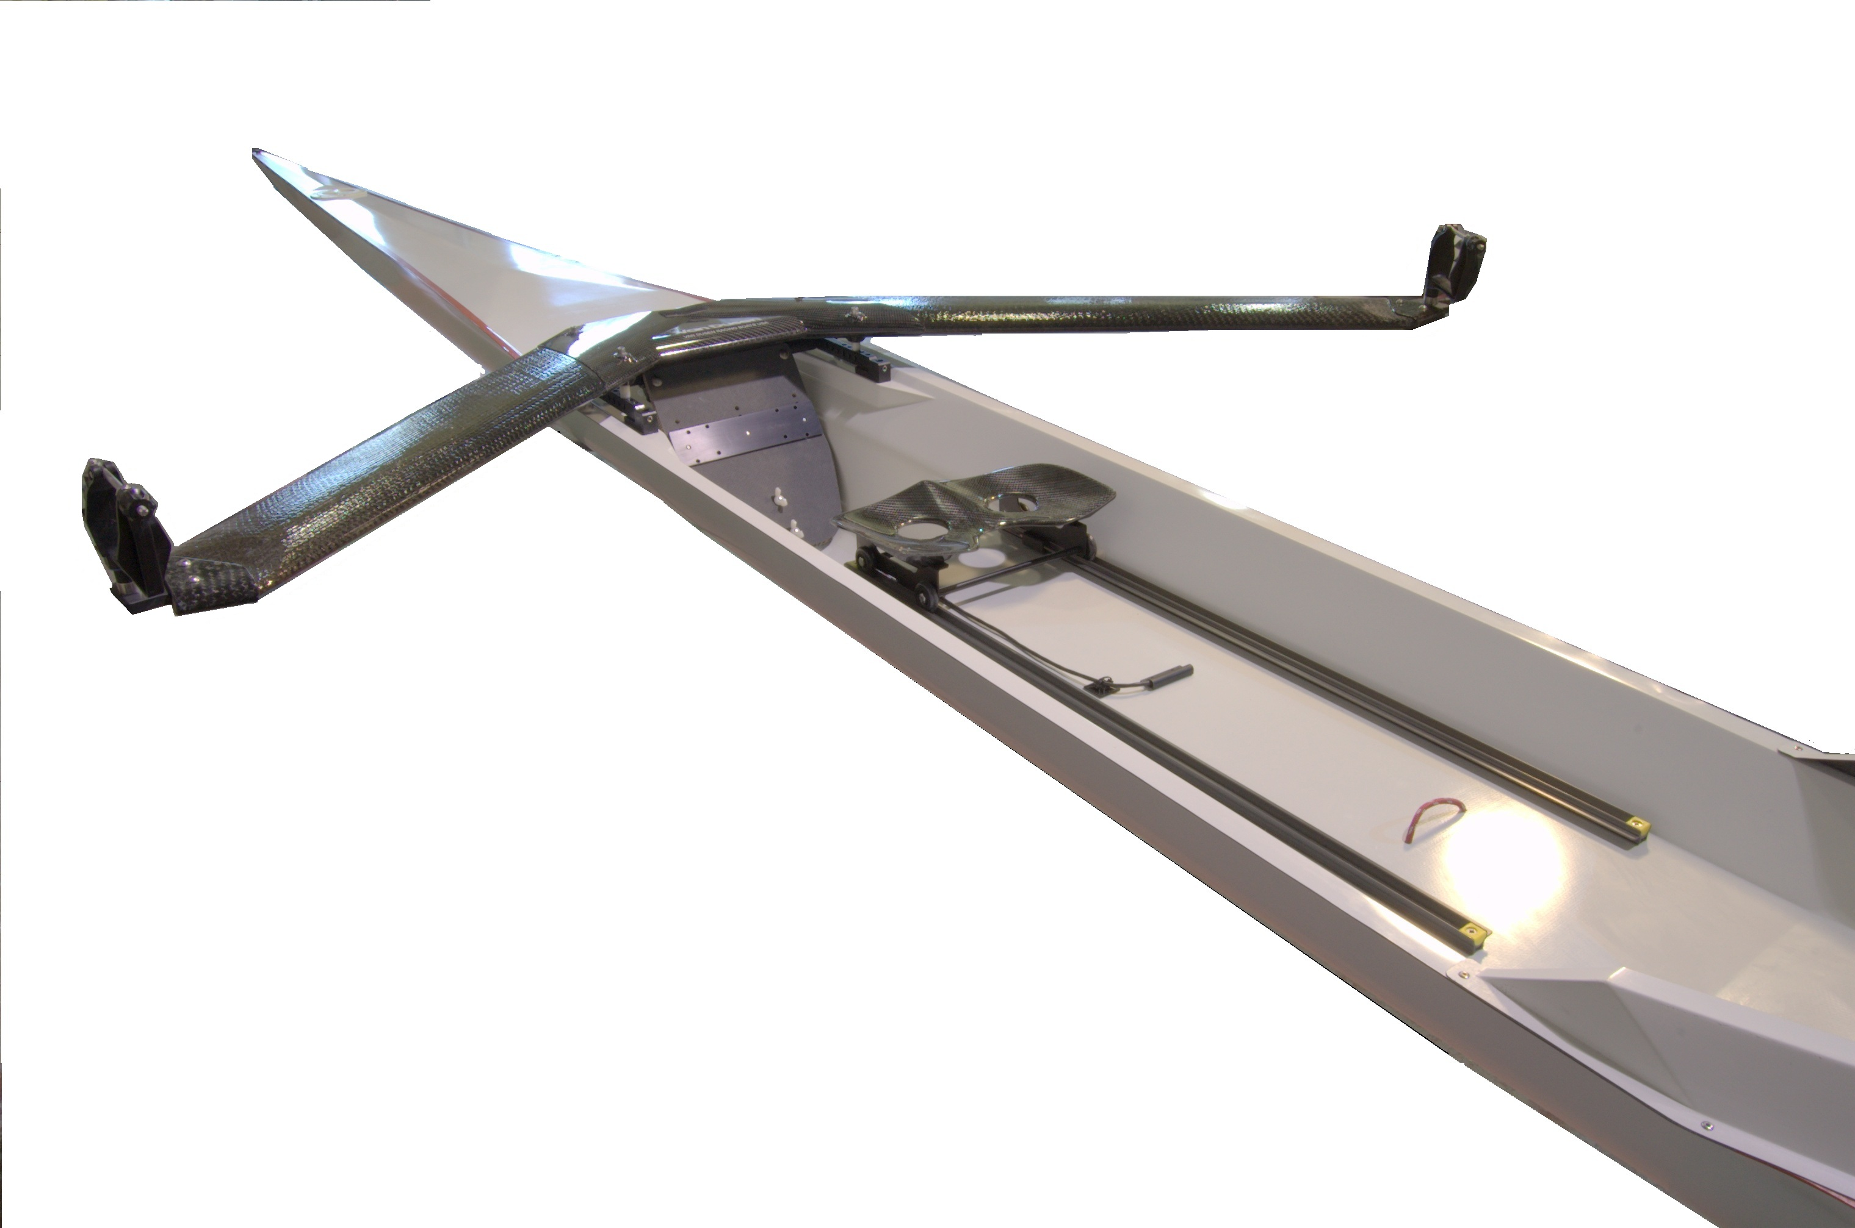

Prices valid through December 31, 2025. Subject to change thereafter.

Van Dusen ADVANTAGE ORDER SPECIFICATIONS – Check or fill in blanks
Your name

Model and Hull Size (see target rower weight)
Flyweight Single (up to 155 lbs.) | Lightweight Double (130-185 lbs.)
Lightweight Single (140-175 lbs.) | Heavyweight Double (170-240 lbs.)
Heavyweight Single (165-220 lbs.) | LW Pair ___________ HW Pair

Please inquire about a custom heavyweight single for rowers > 220 lbs

Wing rigger type (all riggers are black)
Carbon-fiber aerofoil No rigger
I’m interested in titanium hardware (lockplates, shoeplate) for rowing on salt water

Boat Color
Standard Colors: White, Light Grey, Forest Green, Navy (medium) Blue, Light Blue
Hull Color Deck Color (if you are ordering two-tone)
Inspection Port Color (black or white) Tape Color (see page 1 for options, or none)

Rigging Specifications – we will rig to our standards unless you specify otherwise (measurements in cm)
Spread – center to center distance between pins
Outward pitch (angle) of oarlock pin – our standard is 1.5 degrees
Port Stbd Height of oarlock – measured from lowest part of seat top to sill of lock
Vertical distance from lowest part of seat top to heels
Your height ______________ Your weight
Your street shoe size (specify Men’s or Women’s in US sizes, no half sizes)
Footboard options
We stock H2Row shoes (specify men’s, women’s, standard, elite). We have shoe plates to mount other shoe brands and will give credit if you supply your own shoes.
H2Row Shoe (Elite or Standard) (for Men’s Standard specify black or white)
Other brand (e.g. Project B)
I will supply my own shoes (specify the brand)

Seat options
Height of seat carriage (low, medium, high)
Dreher seat top (130 mm) ___________________ Croker seat top (specify 120, 130, or 160 mm hole spacing)

Boat Rack options
Van Dusen Boat Rack ____________________ Rack clamps (set of two)
List your car-top rack (e.g. Thule aero or factory rack - specify height and width of crossbar cross-section)

PRICING WORKSHEET – FILL IN PRICES FROM PAGE 1
Base price (see page 1) $
(Note that cost of accessories and customized items will be added to the final invoice)
Massachusetts sales tax (6.25%) applied to goods delivered or picked up in Massachusetts $
TOTAL ESTIMATE (including sales tax if applicable) $

FIRST DEPOSIT ($500) must be sent with the order form $

SECOND DEPOSIT ($3,500 for a single; $5,500 for a double) must be paid before construction starts. $
BALANCE must be paid before the shell leaves our factory. Please make checks payable to Composite Engineering, Inc.
Payment by check or bank transfer only, no credit cards. Write to vdrbcs@gmail.com for wire payment information. We can send an invoice that you can pay online using your bank account information. All credit card payments are subject to a 3.5% finance charge.

